Milestone Report - Pricing patterns in Produce

INTRODUCTION

A study on the market prices pattern of food produce in two different geographical locations in USA.

San Francisco in the west coast and Atlanta in the east coast. Organic vegetables and fruits are important produce and the major form of food consumption. This study focuses on the organic and conventional prices. Type of market is Terminal market or wholesale market. (A logistics Hub for distribution of Organic produce).

In the current environment, Food is an important attribute of our everyday lives.  The type of food intake will have a direct impact on our health. The world is leaning towards Organic food eventually.

**I want to solve following problems:**

1. What are the **price ranges** of organic vegetables vs Conventional vegetables?
2. What is the **probability of the increase** in price using predictive Analysis?
3. Which **market location has more price difference**?
4. Which **vegetable/fruit is costlier**?

Purpose:

* 1. Understand the organic market prices in two terminal markets(organic)
  2. The price differentiation between conventional prices and organic prices (organic versus conventional)
  3. The consumers will know how to purchase better with data analysis findings.
  4. Individuals /Homes have the predictive retail prices of the produce, they can decide when to buy **produce.** (month-based prices) ( i.e predictive analysis)
  5. How is the correlation in prices between two different geographical locations? (SFO and ATL)

My client will be **Individual wholesale Consumers** who are interested in buying Organic and conventional produce.

The List of Consumers are:

1. Restaurant/Hotel
2. Grocery Retailers
3. Individuals /Home
4. Culinary schools

Below are the list of wholesale Consumers:

<http://www.sfproduce.org/merchants/merchname.html>

<http://terminalmarkets.com/atlantastate.htm>

Statistical Methodology:

1. Descriptive Analysis
2. Predictive Analysis
3. Exploratory Analysis

A basic plot that depicts the Average price pattern of produce in 2013 in two different locations ( San Francisco and Atlanta )

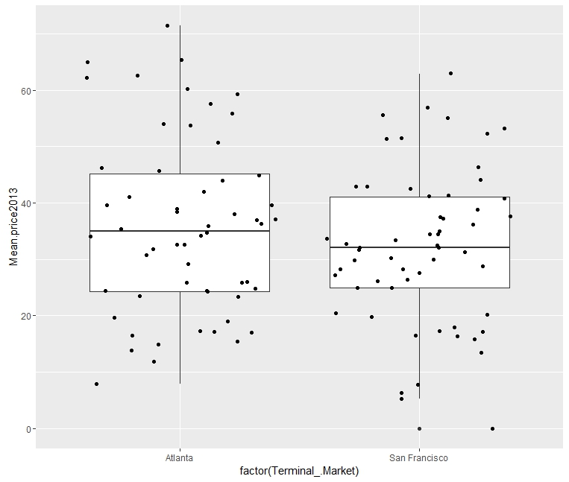

This simple Box plot reflect the average price pattern; the average price is higher at Atlanta than San Francisco.

The scattered points depict the prices of various commodities (vegetables and fruits)

2) A basic Scatter-plot price increase pattern of different commodities: 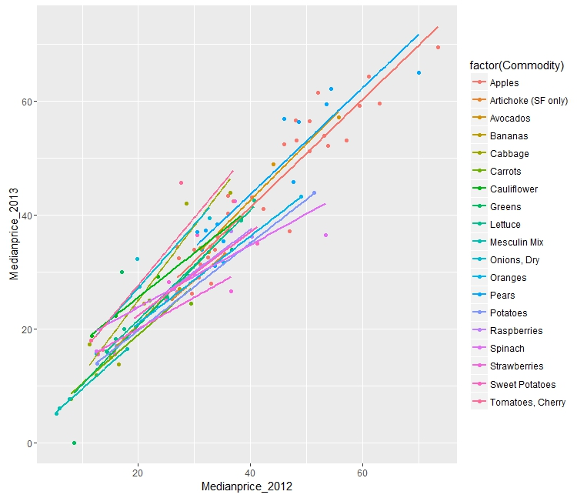

Outcome of Statistical Analysis:

1. Pattern in produce pricing – A comparison of Organic and conventional Produce
2. Do the Geo-graphical locations differ in their pricing pattern? (San Francisco and Atlanta)
3. (consumers can be selective on the seasonal availability/Month=wise pricing) example: Restaurant owners can decide which produce to buy according to the Price increase-decrease and their operating cost.
4. Predictive analysis of prices will help the consumer on the produce prices that are probable to increase
5. Get perspectives on Organic produce. Is it really worth the while of buying organic versus conventional in the long run.